|  |  |
| --- | --- |
| Team ID | B2-2E4M |
| Project Name | Skill/Job Recommender Application |

**Step**:1 Go to IBM Cloud Login Page: [***https: //cloud.ibm.com/login***](https://cloud.ibm.com/login) ,Then Enter Your IBM Id and Passsword

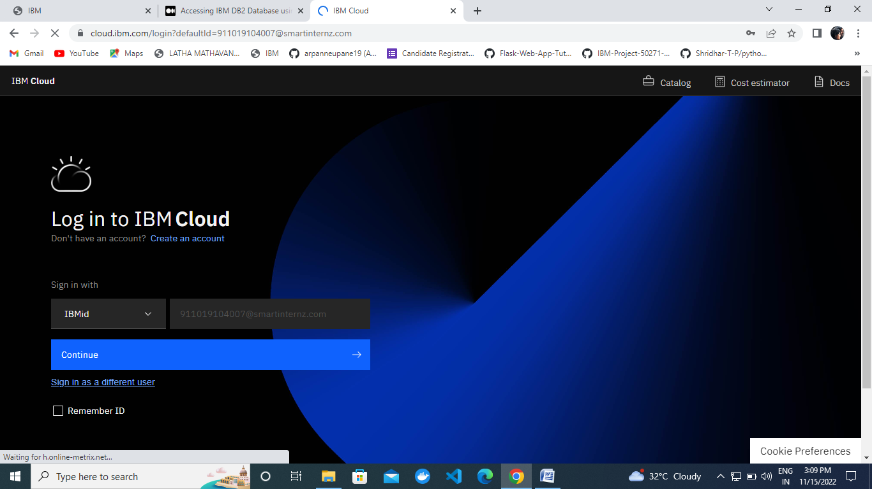

Step 2: Create the IBM Db2 service in the IBM cloud in Free

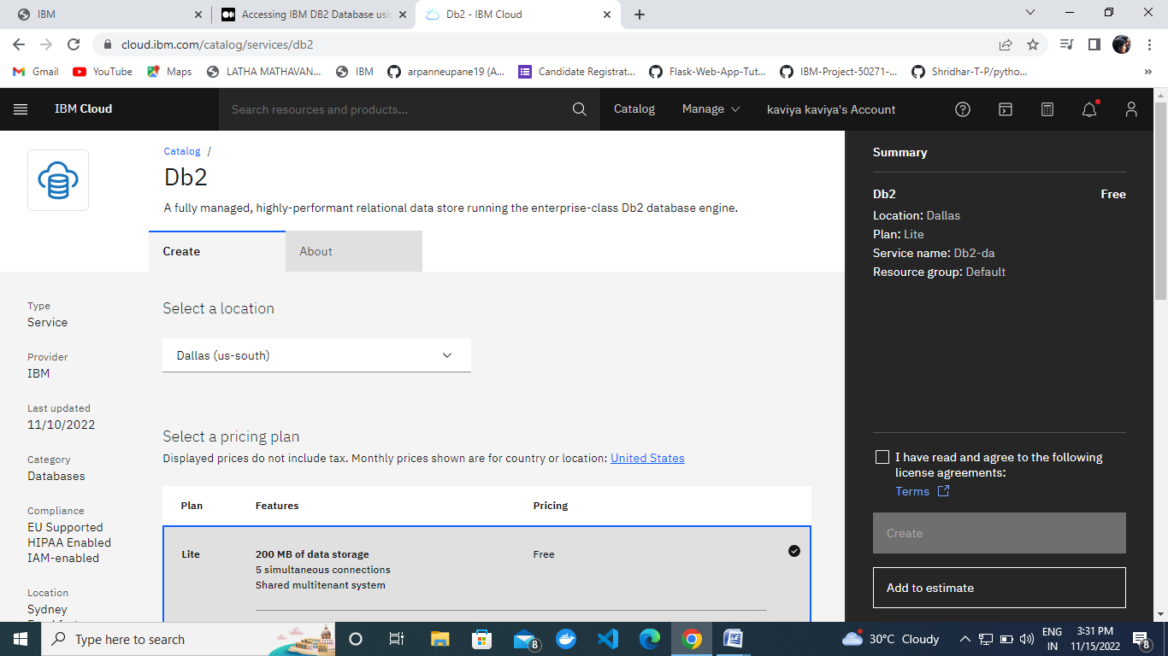

Step 3 : Go To Thr Resource List in Free.

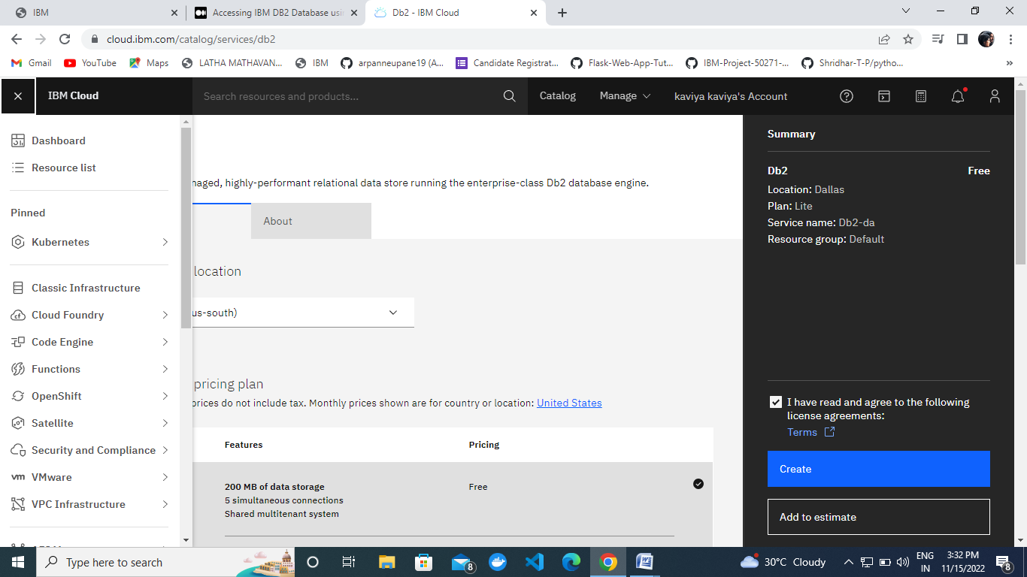

Step: 4 Add to The Database.

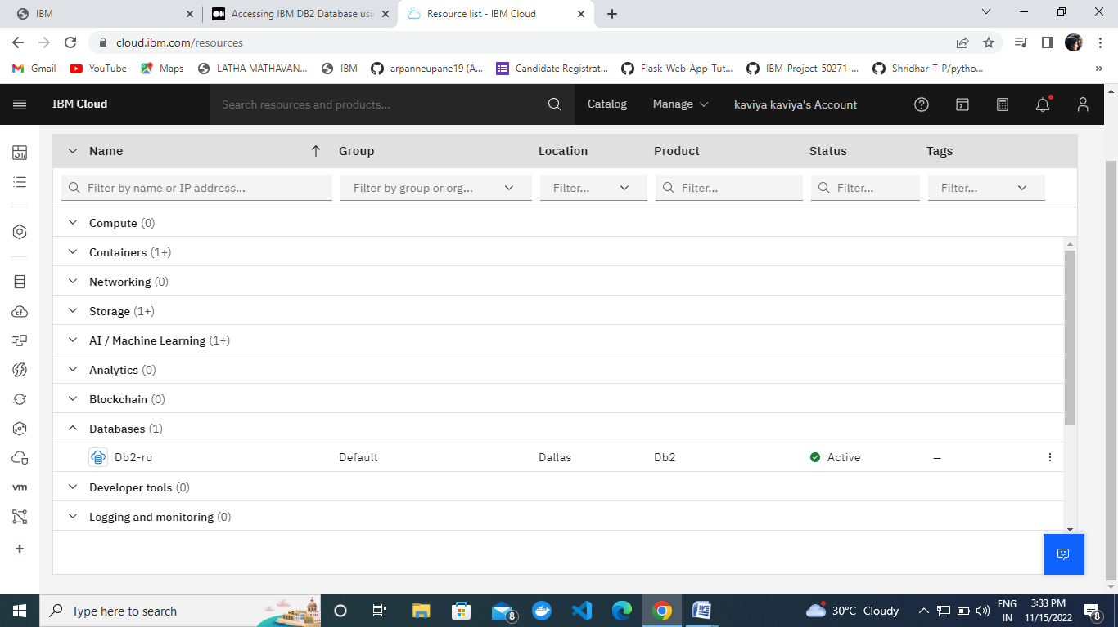

Step:5 Clike Getting Started .

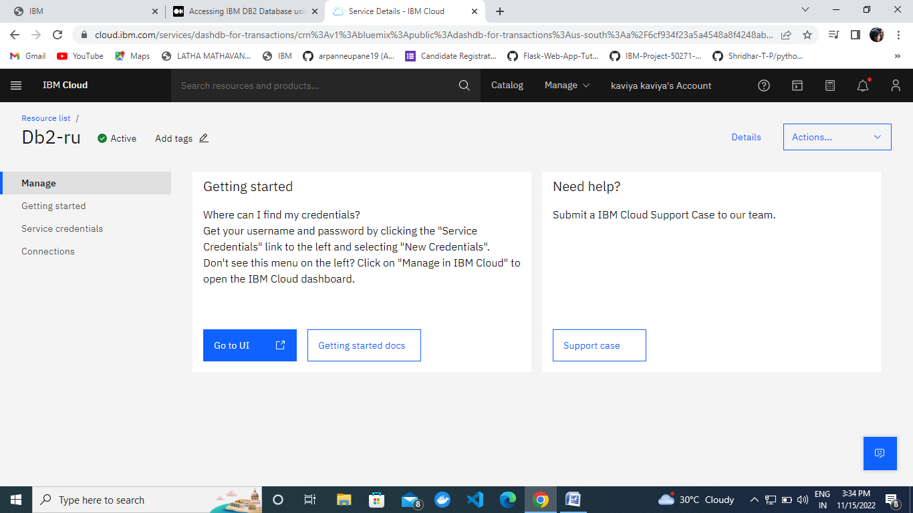

# Step:6 Starting with the Python Code.

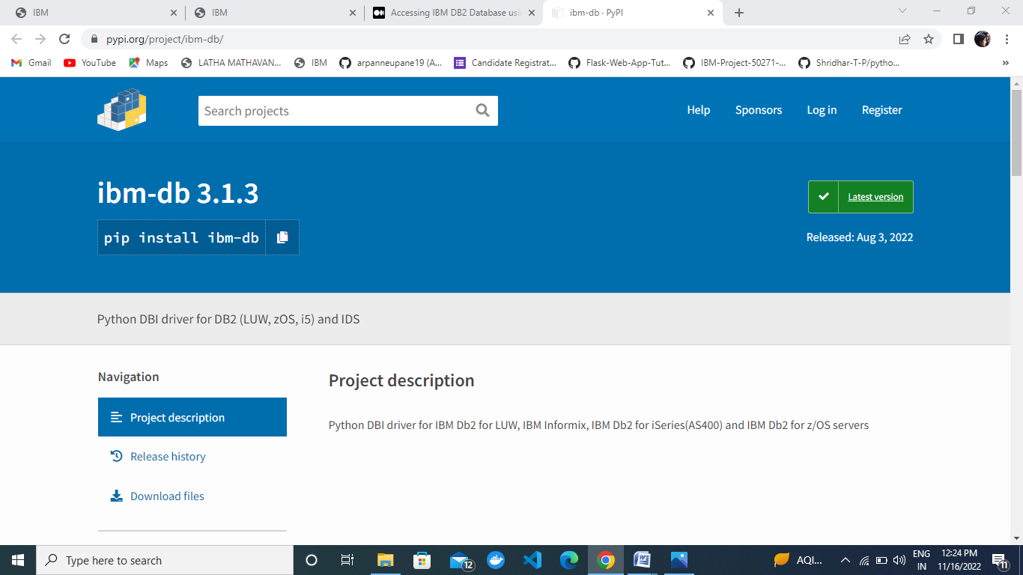

### Step 7: IBM DB2 And Connect With Python

